**MidTerm Object Detection Challenge**

**Team EyeConic**

**Brooke Broderick - W217065417**

**Matthew Choo - W206744145**

**Cameroun White-W216530571**

**Melvis Maduagwu-W216890463**

**Erick Banegas - W2162009**

**NancyChieu-W000098778**

**Yoana Cook - W215913890**

**6252-ITAI-1378-Comp Vision-Artificial Intel-RT-15698 - Spring 2025**

**Professor Anna Devarakonda**

**March 29, 2025**

**Intro:**

In this midterm, we are tasked to enhance the performance of an object detection model with specific constraints. We also then choose to pick any datasets which are PASCAL VOC 2007, COCO-minitrain, Oxford-IIIT Pet Dataset, German Traffic Sign Dataset, and CIFAR-10. Team EyeConic has chosen the Oxford-IIIT Pet Dataset to be used for the object detection model.

**Results**

**Yoana Cook**

I have done three different versions:

Version 1:

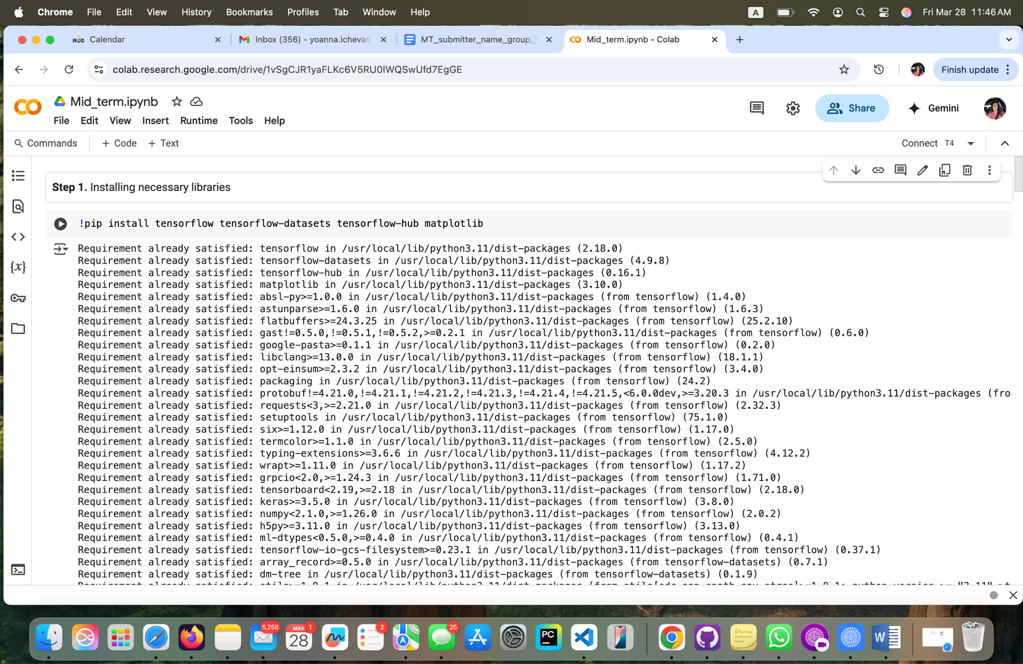

**Version 1; Fig 1. Installing the necessary libraries.**

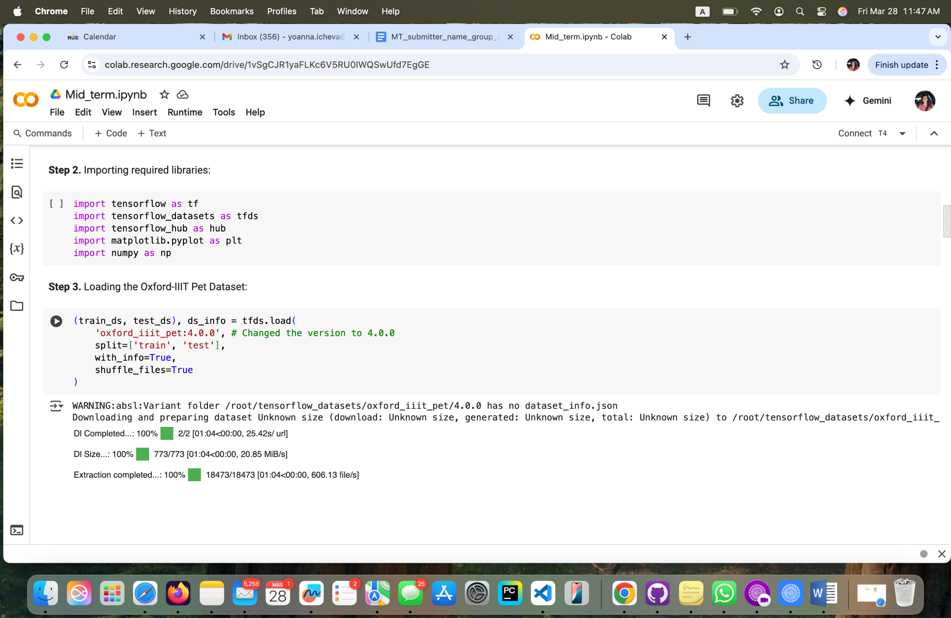

**Version 1; Fig 2. Importing required libraries.**

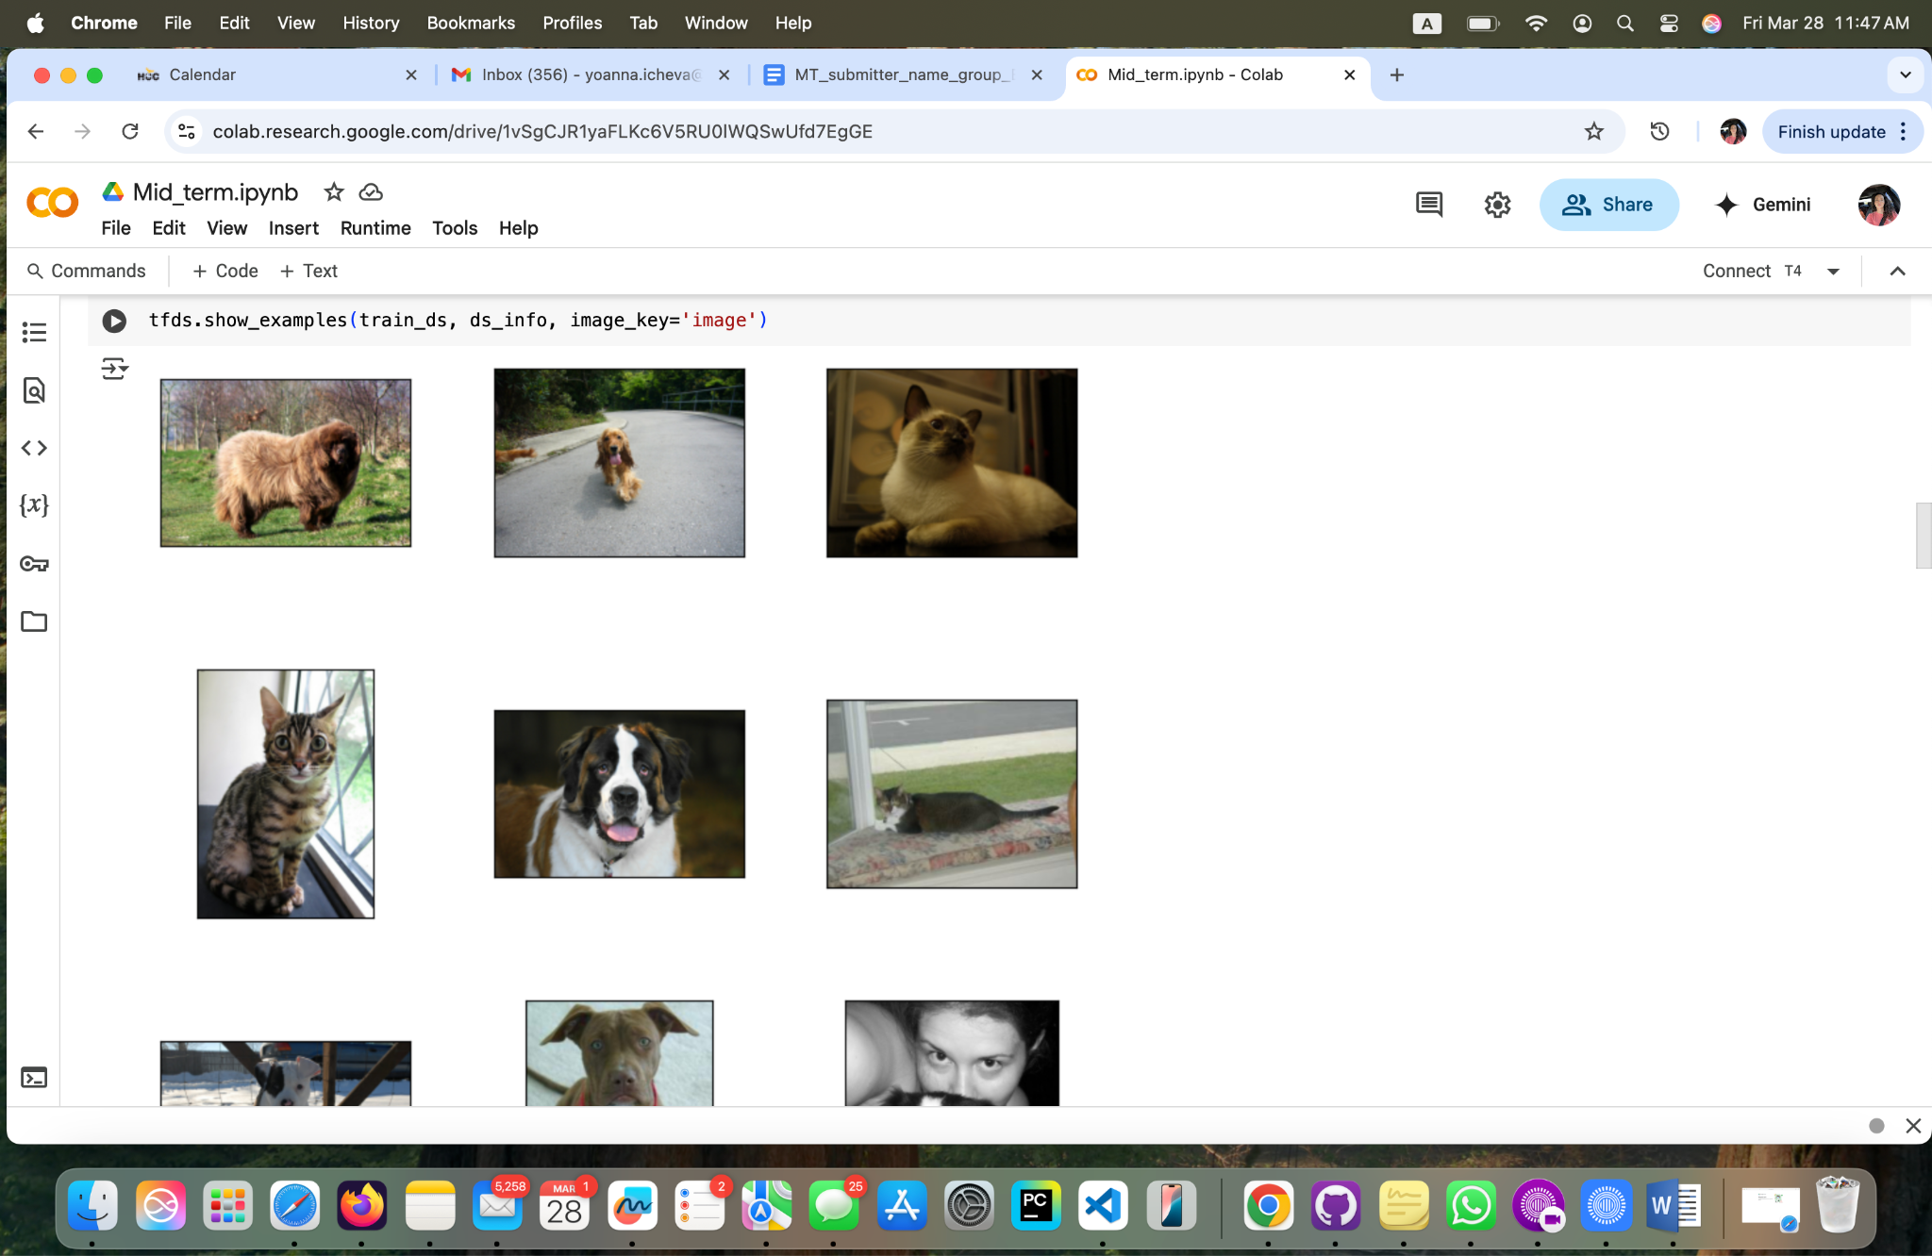

**Version 1; Fig 3. Results**

**Yoana’s Version 2:**

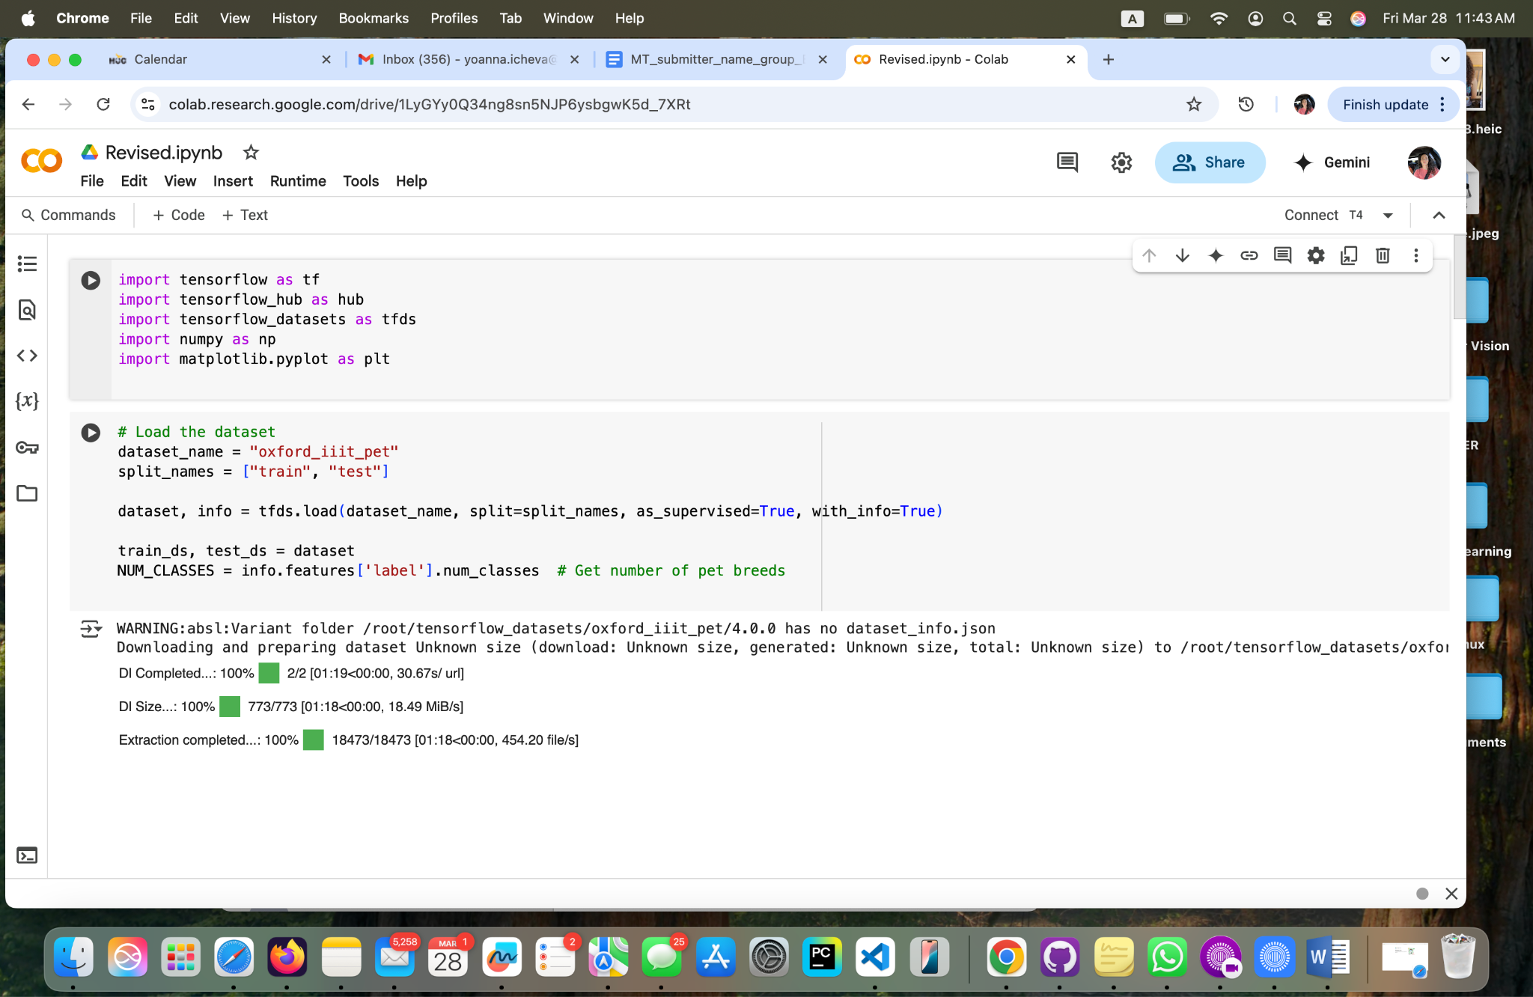

**Version 2 Fig1: Importing necessary libraries and loading the dataset**

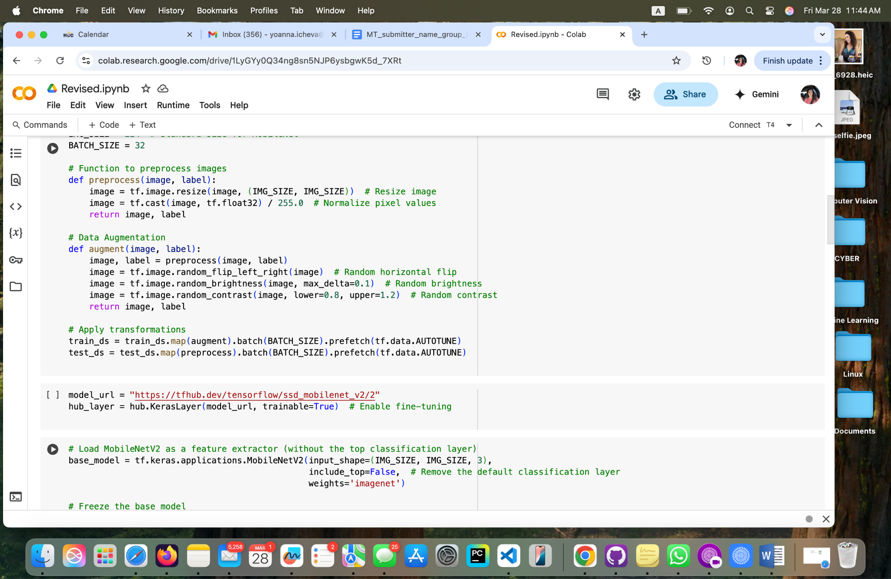

**Version 2; Fig 2. Preprocessing images, augmentation data and applying transformations**

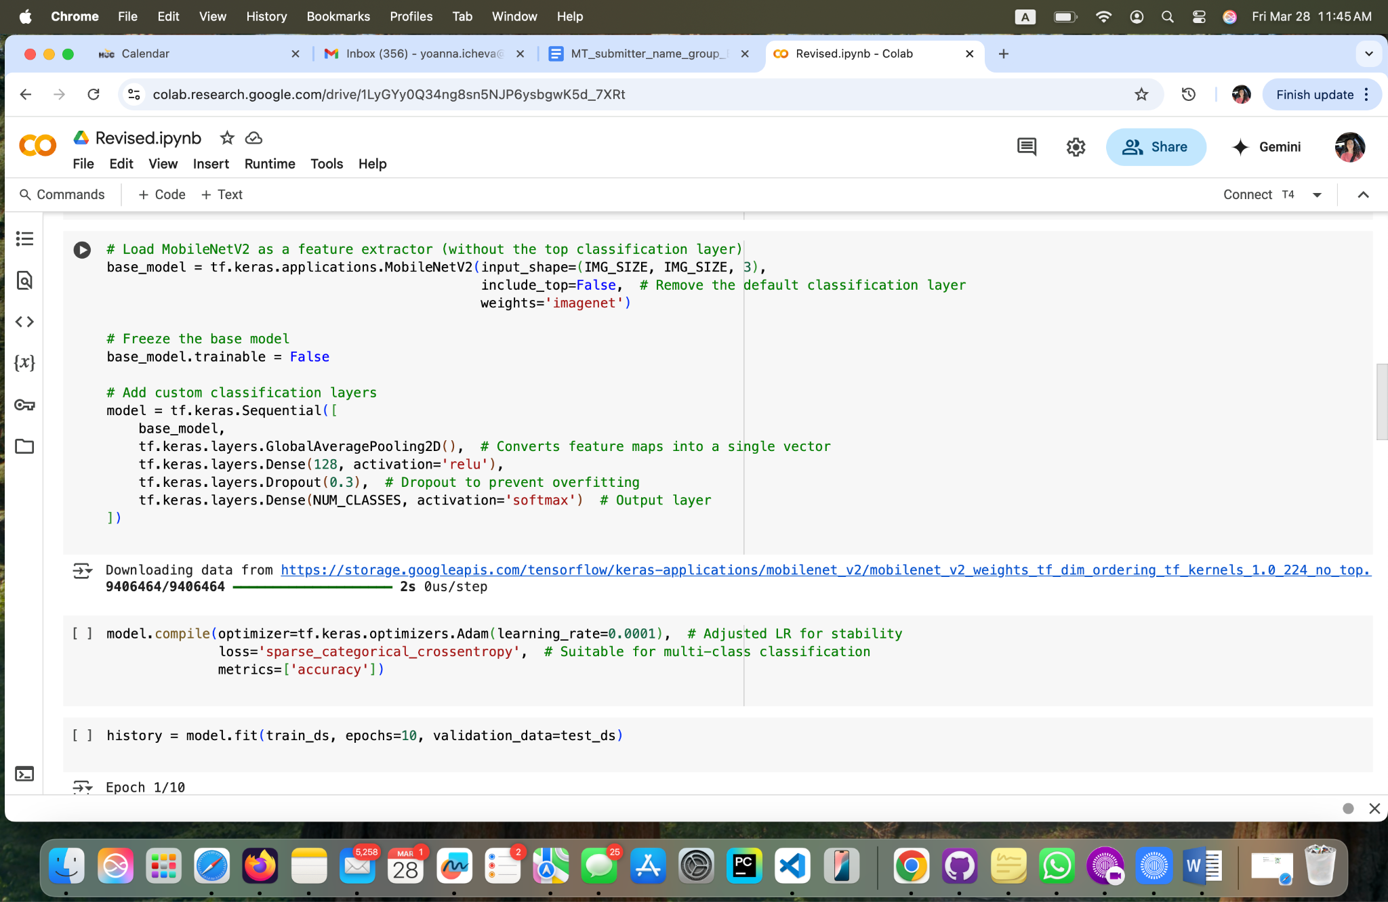

**Version 2; Fig 3. Adding custom classification layers**

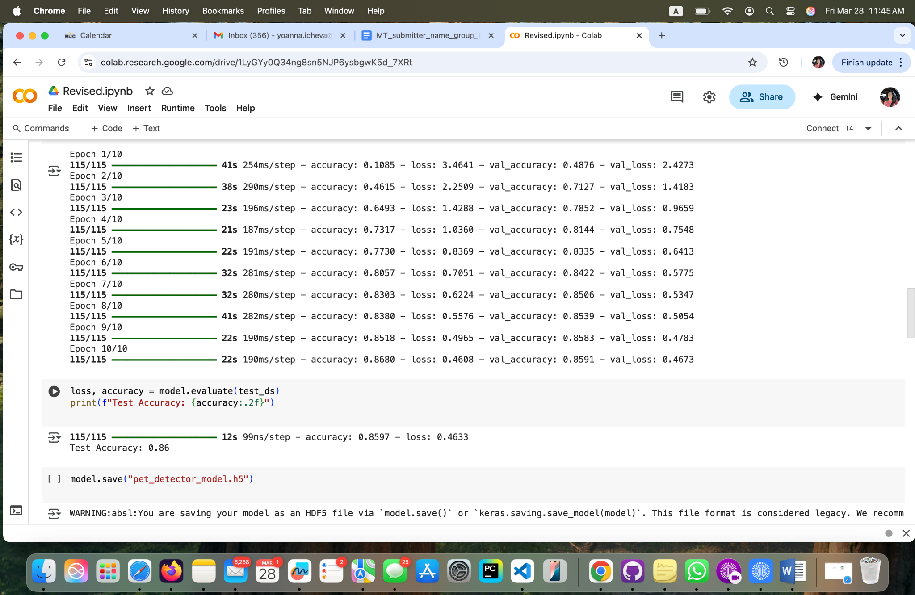

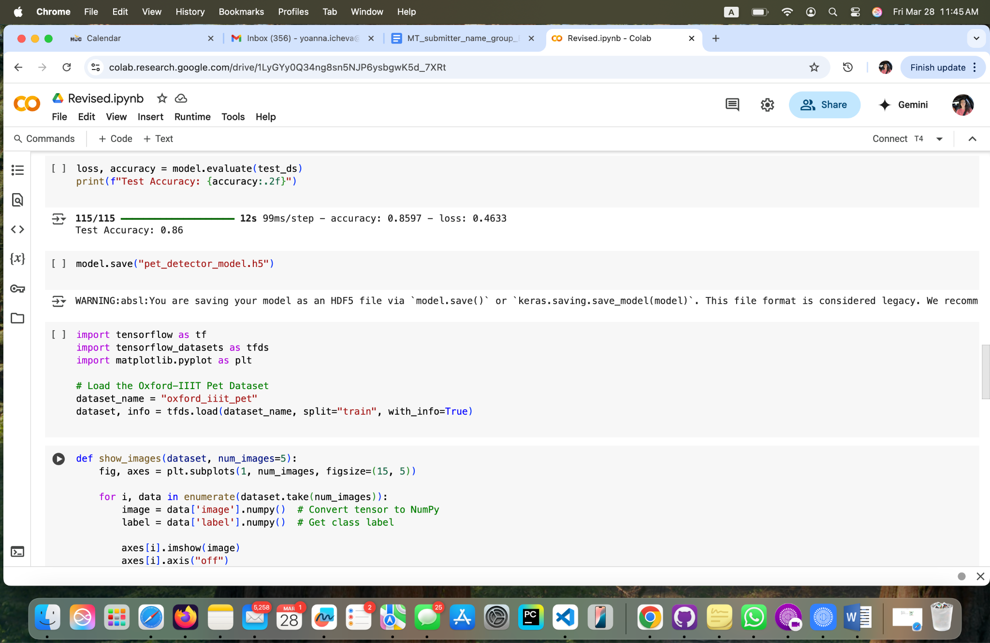

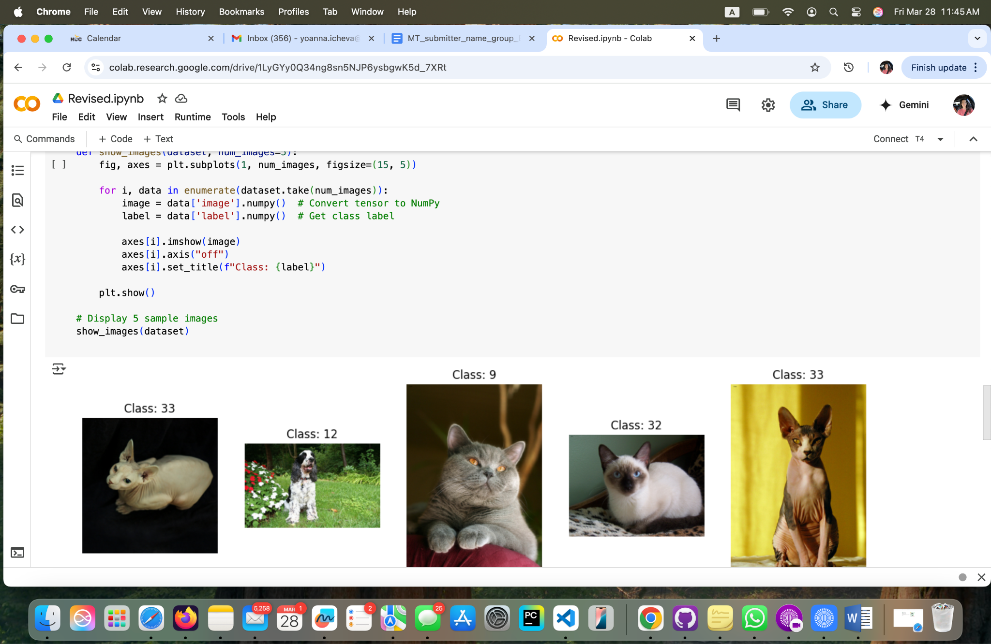

**Version 2; Fig 3. Results**

**Reflection**

**Brooke Broderick** Using the Oxford-IIIT Pet Dataset, we trained and evaluated a model using TensorFlow,

leveraging SSD MobileNet V2. Also, we experimented with fine-tuning methods to enhance detection accuracy, adjusting hyperparameters and freezing/unfreezing specific

layers to optimize feature extraction. The model performed well on common breeds but

struggled with rarer ones due to class imbalance. On the computational side, the model

ran efficiently on a GPU but slowed significantly on a CPU, highlighting trade-offs

between speed and complexity. I also noticed that images with different lighting

conditions negatively impacted performance, though data augmentation techniques like

flipping and brightness adjustments helped. We mitigated these using TensorFlow’s

built-in optimizations, such as data augmentation strategies.

[**MidTerm_Object Detection_Broderick, Brooke_ITAI1378.ipynb**](https://colab.research.google.com/drive/1jo1pO4JnkfziMe6uiTtnKYH6QWlgZ2YL?usp=sharing)

**Matthew Choo**

* Team EyeConic has picked the The Oxford-IIIT Pet Dataset to be used for the detection challenge. We also have to use a file called Student_Notebook_LAB_Object_Detection_transfer_learning.ipynb as a template for the assignment. Had to create three different versions to extract the dataset and use tensorflow on it. There have been some errors from these three but after trial and error, we were able to get results. From figures 1 to figure 11 shows the results with pictures. Next in figures 12 to figure 17 shows the same but different because in figure 1 it had a path for the dataset. Lastly in figures 18 to figures 25 shows a combined version of both figures 1 and 12. When running these three versions, it takes awhile for the dataset to be downloaded in the file. Overall this was an interesting challenge.

[**https://github.com/MattChoo0/Midterm**](https://github.com/MattChoo0/Midterm)

**Cameroun White**

This lab was a very educational approach to object detection from our prior assignment. Our team chose to use the Oxford-IIIT Pet Dataset. We utilized techniques to better the quality of the data and improve the accuracy of detection. Through teamwork and peer support we came to a great end goal. This helps us in being more comfortable in utilizing tools such as Tensorflow. Differentiating three versions was amazing, and using different variations of formats lessens the amount of errors that are presented. While very challenging this was a very insightful project to do.

[**https://github.com/OhMyGodCam/hello-world.git**](https://github.com/OhMyGodCam/hello-world.git)

**Melvis Maduagwu**

* This lab was pretty challenging and interesting . We went in depth on how to use tools like Tensorflow and Tensorflow datasets. We learned how to work with the Oxford-IIIT Pet Dataset and apply preprocessing techniques to improve data quality. Through transfer learning, we explored the capabilities of pre-trained models like SSD MobileNet V2 and experimented with fine-tuning methods to enhance detection accuracy. Additionally, we deepened our understanding of key evaluation metrics, such as mean Average Precision (mAP), and applied post-processing techniques to refine model predictions. Beyond technical skills, we also improved our ability to work collaboratively in a structured project environment. Though we have low resources, I believe with more resources, we could get better results.

[**https://github.com/Melvis-07/Midterm**](https://github.com/Melvis-07/Midterm)

**Erick Banegas**

In this project, I learned the great importance of data preprocessing, especially when working with images of different sizes and formats. I realized that resizing and normalizing images not only prevents technical errors during training but also significantly improves the model's performance. Additionally, I discovered the power of transfer learning by using MobileNetV2 as a base model, which allowed me to build a more efficient and accurate neural network in less time by leveraging knowledge from previously trained models. Finally, by converting the model to TensorFlow Lite and applying quantization, I understood how a model can be optimized to run more efficiently on devices with limited resources, such as mobile phones or embedded systems. This whole process gave me a clearer and more complete understanding of the AI model lifecycle, from training to real-world deployment.

<https://github.com/erickxllx/jupyter-exploration/blob/main/MT_V3.ipynb>

**Nancy Chieu’s Reflection**

Our team has decided to use **Oxford-IIIT Pet Dataset**  as the dataset for object detection

challenge with assigned file: mt.ipynb. We met several times, first to download mt.ipynb

file so that we can test it out on Google Colab again. To our surprise that we found the

whole process is similar to L09 Object Detection using Transfer learning and Pascal VOC

2007 Dataset. After several team meetings to test V1, V2, and V3, I also tested out the

process in the first step and had to enable TPU (Tensor Processing Unit) in Colab by

changing Runtime to TPU under the menu in Colab. I still ran into errors and had to follow

the suggestion to rerun some codes again. It was time consuming and I had to read the codes

over and over again and encountered several trials and errors. However, we did not have to

do data cleaning by choosing the good dataset: **Oxford-IIIT Pet.** It guided us through the

the whole process except there were some steps required a long download. I saved my result:

[**https://github.com/nchieu2025/jupyter-exploration/mt.ipynb**](https://github.com/nchieu2025/jupyter-exploration/mt.ipynb)

**Yoana Cook**

Throughout this project, I explored different approaches to working with the Oxford-IIIT Pet Dataset using TensorFlow and TensorFlow Datasets (TFDS). The process evolved through multiple iterations, refining both functionality and efficiency along the way.

In the initial notebook (*Mid_term.ipynb*), I focused on establishing a structured workflow, ensuring clear documentation at each step. This included installing necessary libraries, importing modules, and loading the dataset with explanations. This version was valuable for understanding the dataset's structure and familiarizing myself with TFDS.

The second iteration (*midterm.ipynb*) streamlined the process significantly. It stripped away markdown explanations and focused purely on dataset loading. While this made the notebook more concise, it lacked the contextual guidance present in the first version. This iteration was a useful stepping stone for refining the approach but needed further development.

The final revision (*Revised.ipynb*) introduced significant improvements. In addition to dataset loading, this version I have incorporated essential data preprocessing techniques, including resizing images, normalizing pixel values, and applying data augmentation (random flips, brightness adjustments, and contrast modifications), of course with help of ChatGpt, helping understand the concepts and techniques. Additionally, batching and prefetching were implemented to enhance training efficiency. While this version cut out markdown explanations, it represented a more optimized and ready-to-use implementation.

Overall, this progression highlights the importance of iteration in coding. The first version emphasized clarity and documentation, the second focused on minimalism, and the final version balanced functionality with efficiency. Moving forward, a combination of thorough documentation and optimized implementation would ensure both clarity and performance in future projects.

[**https://github.com/YoanaKC/The-eagles/blob/main/Mid_term.ipynb**](https://github.com/YoanaKC/The-eagles/blob/main/Mid_term.ipynb)

[**https://github.com/YoanaKC/The-eagles/blob/main/Revised.ipynb**](https://github.com/YoanaKC/The-eagles/blob/main/Revised.ipynb)

[**https://github.com/YoanaKC/The-eagles/blob/main/midterm.ipynb**](https://github.com/YoanaKC/The-eagles/blob/main/midterm.ipynb)

**Bibliography**

Ilovescience. “The Oxford-IIIT Pet Dataset.” Kaggle, 29 Jan. 2019,

[www.kaggle.com/datasets/tanlikesmath/the-oxfordiiit-pet-dataset](http://www.kaggle.com/datasets/tanlikesmath/the-oxfordiiit-pet-dataset)